|  |  |
| --- | --- |
| **DOCUMENT RULES:** | |
| **Task Number / Name:** | **Docker Containers** |
| **Task name & column name should be written:** | **Bold (CTRL+B)** |
| **Commands should be written in the after # sign:** | *Italic (CTRL+I) #hostname* |
| **Output photo should be cropped or compressed:**  **Photo could be more than one:**  **If you need extra lines, add the line next after it:** | ***Description photo should be with title bar (CTRL + I + B)*** |
| **All other text should be written:** | Standard |
| **Font name and text size:** | Calibri and 9 |
| **Group name:** | Dev_ops_ |
| **Student name and surname:** | Murad Abbaszade |
| **E-mail:** | [muradabbaszade6@gmail.com](mailto:muradabbaszade6@gmail.com) |
| **WhatsApp number:** | **+994703664205** |

Docker Containers

Pull Ubuntu Image with latest version.

Docker pull ubuntu:latest

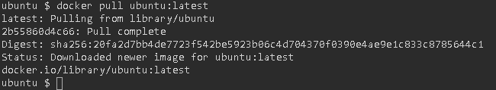

To see list of all available images instruct docker with below command.

docker images



## Run Container from Ubuntu Image.

#### To run container from Ubuntu image, instruct docker with command:

docker run ubuntu:latest

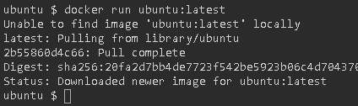

Now check whether container is running or not?

docker ps



You will find that container is in stop mode.

docker ps -a



run container.

docker run -t -i --name=tutorial ubuntu:latest



Install golang and dependencies inside containers

Now, download or install golang programming language.

wget <https://go.dev/dl/go1.18.3.linux-amd64.tar.gz>

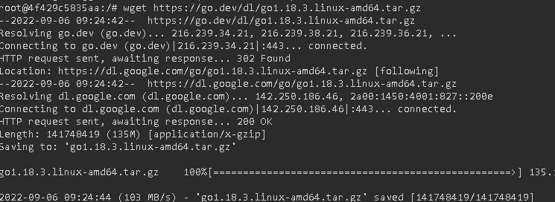

Run the below command to extract files.

tar xvf go1.18.3.linux-amd64.tar.gz

Move this go/ directory inside /usr/local/

mv go/ /usr/local/



*go version*

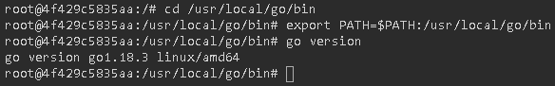

## Write hello world program

#### Crete new directory

mkdir hello

#### Create file with name main.go

vim main.go

#### paste the below code,

package main

import "fmt"

func main() {

fmt.Println("Hello, World!")

}

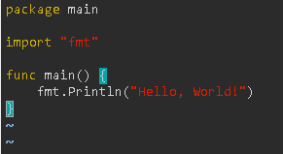

Execute the program --> go run main.go



Create image manually from stopped Containers

To stop container, write below command inside your container.

Exit

Is there any way to come out of container without stopping it ? Yes,

press "ctrl p+q" at the same time

Is there any way to go inside any running container? Yes,

docker attach tutorial

To create Image from it. Run the below command:

docker commit tutorial tutorial-image

Check whether "tutorial-image" is present or not:

docker images